**Names: ____________________________, _________________________________**

|  |  |  |
| --- | --- | --- |
|  | **Computer Simulation: Collisions in Two Dimensions**  In this experiment you will be using the *PHET* simulation *Collision Lab* to explore the relationships between the momentum, impulse, and kinetic energies during two-dimensional collisions. | Picture 4 |

**Objectives**:

• add momentum vectors – by components and by vector addition

• apply the Law of Conservation of Momentum

• determine the impulse on an object involved in a collision

• determine the role of elasticity on the outcome of collisions

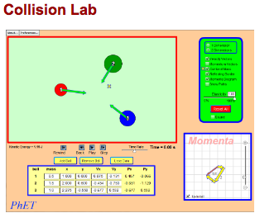

**Description**

The simulation allows you to change the velocity and mass of up to five balls that will collide in two dimensional collisions. When you open the simulation make the following setting changes:

• activate *velocity* and *momentum* vectors

• activate the *momenta diagram*

• deactivate the *reflecting border*

# PreRequisite Skills: *Momentum and Impulse*

• Newton’s first law can also be phrased in terms of momentum: for any closed system of objects, the total momentum remains ____________________. Note that momentum *can* be exchanged between objects within a closed system. However, the magnitude of the change in momentum for one object must be _________________ to the magnitude of the change in momentum of the other object.

• A change in momentum for an object is also referred to as an _____________________________.

• Fill in the appropriate units for each quantity: momentum: ___________ impulse: ____________

# Settings: Use the Advanced tab. Select 2 Dimensions, Velocity Vectors, Center of Mass, Reflecting Border, Momenta Diagram and Kinetic Energy. Select MORE DATA. Check “tip to tail” on Momenta.

# momenta diagExploration:

**1.** Begin with two balls of equal mass with the second ball at rest. Set the first ball to collide obliquely. Run several trials varying the velocity and amount of obliqueness. What can you say about the relationship between the directions of the two balls after the collision? Demonstrate your observation by copying a sample Momenta Diagram. Determine what four conditions are necessary for this to occur?

_____________________________________________________

_____________________________________________________

_____________________________________________________

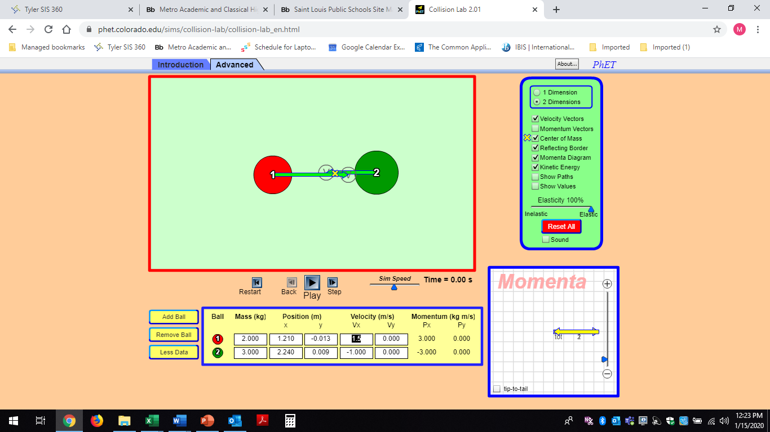

**2.** Now change to masses of 2kg and 3 kg and uncheck “tip to tail”. Change the velocity of each ball (by dragging on the velocity vector or by selecting appropriate velocity components and initial positions) until the total momentum is close to zero as indicated on the Momenta Diagram. Move the three arrows so they are all visible. Adjust the scale on the Momenta Diagram until your arrows just fit inside the grid, then copy the vector diagram in the space to the right.

**3.** Set the Elasticity to 0.0, then run the simulation. Describe what happens to the motions of the balls after the collision. How does this relate to the motion of the center of mass? What happened to the *Momenta Diagram*?

__________________________________________________________________________________

__________________________________________________________________________________

__________________________________________________________________________________

Rewind and run the simulation again. Record the total initial and final kinetic energies of the system in the spaces below.

** **

**4.** Rewind, set the Elasticity to 50%, and run the simulation again. Record the total initial and final kinetic energies of the system in the spaces below.

** **

Rewind, set the Elasticity to 100%, and run the simulation again. Record the total initial and final kinetic energies of the system in the spaces below.

** **

Describe the effect the elasticity had on the motions of the balls after the collision.

__________________________________________________________________________________

__________________________________________________________________________________

Did the elasticity affect the total momentum of the balls after the collision? Explain._______________

__________________________________________________________________________________

How did the elasticity affect the momentum of each of the balls after the collisions? ______________

__________________________________________________________________________________

# momenta diagAnalysis: Two Dimensional Collisions

**1.** Use two balls, with masses of 2kg and 3 kg and recheck tip to tail. Change the velocity of each ball (by dragging on the velocity vector) such that there is a significant, ***non-zero***, total momentum, and that their initial directions are not along either axis (not purely east/west or north/south). Arrange the initial locations of the balls so that will collide ***obliquely***!

Adjust the scale on the *Momenta Diagram* until it just fits inside the grid, then copy the vector diagram in the space to the right. Label vectors with 1 and 2.

**2.** Activate the *more data* button. Transfer the data into the table below then calculate the total momentum *and* direction of each ball.

|  |  |  |  |  |
| --- | --- | --- | --- | --- |
| EK = | **Before the Collision** | | | |
| J | **2 kg Ball** | | **3 kg Ball** | |
|  | x (m) | y (m) | x (m) | y (m) |
| Component  Positions |  |  |  |  |
|  | **v**x (m/s) | **v**y (m/s) | **v**x (m/s) | **v**y (m/s) |
| Component Velocities |  |  |  |  |
|  | **p**x (kgm/s) | **p**y (kgm/s) | **p**x (kgm/s) | **p**y (kgm/s) |
| Component Momenta |  |  |  |  |
| Total Momentum | *calculation:* | | *calculation:* | |
| Direction (°) | *calculation:* | | *calculation:* | |

momenta diag **3.** Set the *elasticity* to 70% and run the simulation.

**4.** Draw the resulting *Momenta Diagram* at the right.

**5.** Transfer the data into the table below then calculate the total momentum *and* direction of each ball.

|  |  |  |  |  |
| --- | --- | --- | --- | --- |
| EK = | **After the Collision** | | | |
| J | **2 kg Ball** | | **3 kg Ball** | |
|  | **v**x (m/s) | **v**y (m/s) | **v**x (m/s) | **v**y (m/s) |
| Component Velocities |  |  |  |  |
|  | **p**x (kgm/s) | **p**y (kgm/s) | **p**x (kgm/s) | **p**y (kgm/s) |
| Component Momenta |  |  |  |  |
| Total Momentum | *calculation:* | | *calculation:* | |
| Direction (°) | *calculation:* | | *calculation:* | |

**3.** Verify the Elasticity of the Collision:

Using the Data given by the simulation for the EKi and EKf you recorded using Show Kinetic Energy.



Using the Show Values option, record the magnitude of the speeds and masses below and calculate the elasticity directly.



How do these calculated elasticities compare to the elasticity set in the simulation? ._______________

__________________________________________________________________________________

__________________________________________________________________________________

**4.** Apply the Law of Conservation of Momentum to analyze the collision in two ways: 1) by components, and 2) using a vector diagram.

Component Method Demonstrate by finding the total px and the total py before and after.

|  |  |
| --- | --- |
|  |  |
|  |  |

Was momentum conserved in each component directions? ___________________________________



Vector Addition: (Use the data from the component method above.)

|  |  |
| --- | --- |
| Total Initial Momentum | Total Final Momentum |

|  |  |
| --- | --- |
| Calculation – magnitude *and* direction | Calculation – magnitude *and* direction |

|  |  |
| --- | --- |
|  |  |

Was total momentum conserved within the limits of accuracy in the simulation? ________________

**5.** Calculate the magnitude and direction of the impulse on the 2 kg ball.

(Breadcrumbs: Record the data for the initial and final momentum vectors for the 2 kg ball. Determine the opposite of the initial momentum. Add the opposite of the initial momentum to the final momentum both graphically and analytically.)

vector diagram calculation (magnitude direction)

**6.** Calculate the magnitude and direction of the impulse on the 3 kg ball. (Hint: your result should be equal and opposite to your answer to 5.

vector diagram calculation (magnitude *and* direction)

**7.** Compare the magnitude and direction of the impulse on each ball during the collision. How do the impulses relate to Newton’s 3rd Law?

_________________________________________________________________________________

__________________________________________________________________________________

__________________________________________________________________________________

__________________________________________________________________________________

**Conclusion:**

Summarize, in a brief paragraph, what relationships you have learned from this simulation. Address each of the lab objectives.